**CONVERSION OF MECHANICAL ENERGY INTO ELECTRICAL ENERGY USING PIEZOELECTRIC**

by

AAYUSH KUMAR 17BEE1022

ISHAAN SHEKHAR 17BME1021

SHASHANK BHARDWAJ 17BME1068

A project report submitted to

**JOHN KENNEDY L**

**SCHOOL OF ADVANNCED SCIENCES**

in partial fulfilment of the requirements for the course of

**PHY1999 – INTRODUCTION TO INOVATIVE PHYSICS**



**VIT UNIVERSITY, CHENNAI**

**Vandalur – Kelambakkam Road**

**Chennai – 600127**

**MARCH 2018**

**BONAFIDE CERTIFICATE**

Certified that this project report entitled “**CONVERSION OF MECHANICAL ENERGY INTO ELECTRICAL ENERGY USING PIEZOELECTRIC”** is a bonafide work **of AAYUSH KUMAR 17BEE1022 , ISHAAN SHEKHAR 17BME1021 , SHASHANK BHARDWAJ 17BME1068** who carried out the Project work under my supervision and guidance.

**John Kennedy L**

Associate Professor

School of Advanced Sciences (SAS),

VIT University, Chennai

Chennai – 600 127.

**ABSTRACT**

A piezoelectric plate is a device that uses the piezoelectric effect to measure pressure, acceleration, strain or force by converting them to an electrical charge. Piezoelectricity is the electricity generated by piezo element by effect called the piezoelectric effect. It is the ability of certain materials to generate an AC (alternating current) voltage when subjected to mechanical stress or vibration, or to vibrate when subjected to an AC voltage, or both.

The purpose of our project is to create a device that harvests ambient energy sources into usable electrical energy. We have decided to create a floor mat that will absorb the mechanical energy of people walking across it in order to create electrical energy. This can be accomplished by placing piezoelectric materials inside the mat, or in conjunction with the mat. For this project, we are required to create a prototype that proves the concept of energy harvesting devices. Our goal is to generate enough energy with our mat to power an LED. Our purpose is more educational in order to see how efficient our floor mat is and see what type of electronics can be powered based on how efficient our floor mat is.

We will be implementing this by developing a mat to convert mechanical energy to electrical energy by placing piezoelectric crystals in the mat that produce an electric impulse when stretched or deformed.

The piezoelectric mat is a way to reduce energy costs by harvesting the energy people use while walking. We can create this energy by using the mat to capture the mechanical compression of people walking and turn it into power.

**ACKNOWLEDGEMENT**

We wish to express our sincere thanks and deep sense of gratitude to our project guide, **John Kennedy L,** Associate Professor, School of Advanced Sciences, for his consistent encouragement and valuable guidance offered to us in a pleasant manner throughout the course of the project work.

We also take this opportunity to thank all the faculty of the School for their support and their wisdom imparted to us throughout the course.

We thank our parents, family, and friends for bearing with us throughout the course of our project and for the opportunity they provided us in undergoing this course in such a prestigious institution.

**AAYUSH KUMAR ISHAAN SHEKHAR SHASHANK BHARDWAJ**

**TABLE OF CONTENTS**

|  |  |  |  |
| --- | --- | --- | --- |
| **SERIAL NO.** |  | **NAME** | **PAGE NO.** |
|  |  | ABSTRACT | 3 |
|  |  | ACKNOWLEDGEMENT | 4 |
|  |  |  |  |
| 1 |  | INTRODUCTION | 6 |
|  |  |  |  |
|  | 1.1  1.2 | OBJECTIVES AND GOALS  BENEFITS | 6  6 |
|  | 1.3 | COMPONENTS | 6 |
|  |  |  |  |
|  |  |  |  |
| 2  3 | 2.1  2.2  3.1  3.2 | DESIGN  FINAL PRODUCT  HARDWARE ANALYSIS  CONCLUSION  AND EXTRA FEATURS | 7-8  7  7-8  9  9-10 |

1. **INTRODUCTION**

**1.1 OBJECTIVES AND GOALS**

We know that by using piezoelectric plates, we can easily convert the mechanical energy produced by force generated by stepping on the mat.

Using this idea, we will be depicting the conversion, we will also be converting the AC component into DC component.

We will be glowing LEDs using this electrical energy.

**1.2 BENEFITS**

Using the piezoelectric powered mat in places with high density of people, we can create good amount of energy free of cost. According to Wikipedia, 3,50,000 people use the Chennai Central Terminus daily. An usual piezoelectric disc generates about 1 to 2 Volts and 50 to 100 milli Amps current. So the power generated on a single press is equal to 0.05 Watts using the formula P=V*I, V and I being the Voltage and Current respectively. If we consider 1 press (or 1 step) in 1 second, 150 Watt hour of power will be generated using a single piezo disc. This is a really good amount of free energy that we can generate and use. Just by using 2 such discs, the Chennai Central Terminus could generate 25 units of energy.

**1.3 COMPONENTS**

* Piezoelectric Elements
* Wires
* Capacitors
* Diodes
* Mat Sheets
* Foam Push Up
* Breadboard
* Bulbs and LEDs
* Other general items

**2 ADVANCED ROAD AND STREET MANAGEMENT SYSTEM DESIGN**

**2.1 What the final product looked like**

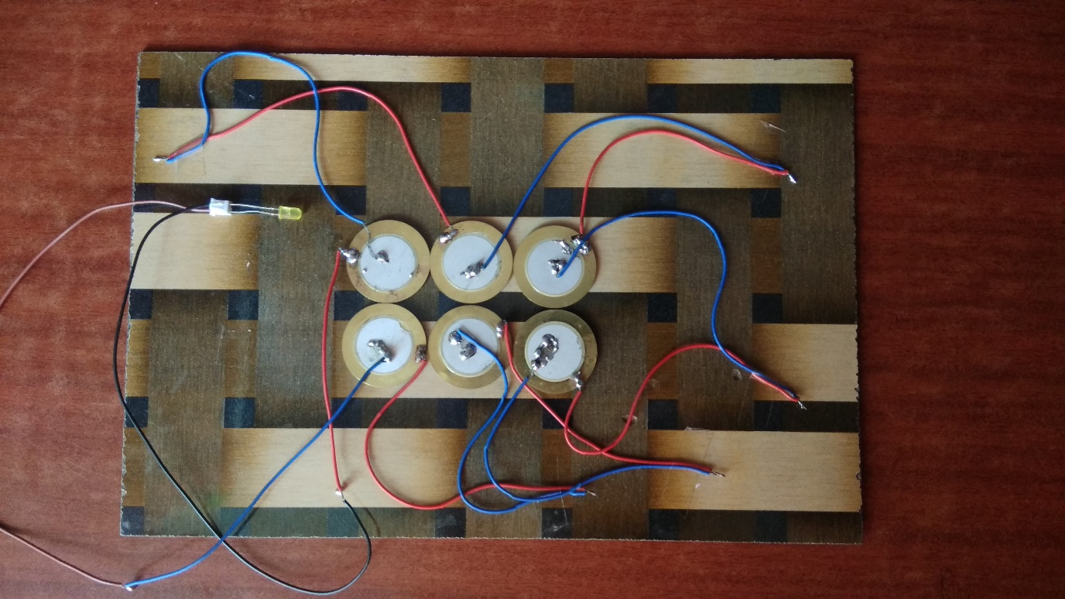

Fig. Piezoelectric mat

**2.2 Hardware analysis**

**2.2.1 PIEZOELECTRIC TILES**

1. Normally, the charges in a piezoelectric crystal are exactly balanced, even if they’re not symmetrically arranged.
2. The effects of the charges exactly cancel out, leaving no net charge on the crystal faces. (More specifically, the **electric dipole moments**—vector lines separating opposite charges—exactly cancel one another out.)
3. If you squeeze the crystal (*massively* exaggerated in this picture!), you force the charges out of balance.
4. Now the effects of the charges (their dipole moments) no longer cancel one another out and net positive and negative charges appear on opposite crystal faces. By squeezing the crystal, you’ve produced a voltage across its opposite faces—and that’s piezoelectricity!

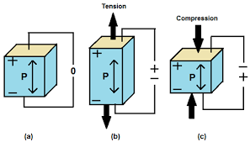

Fig. Depiction of working of piezoelectric disc

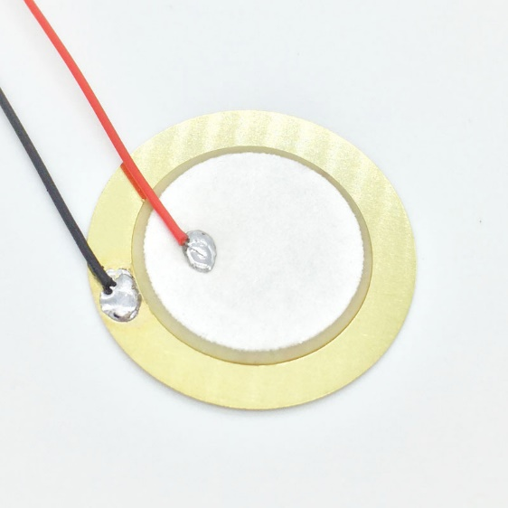

Fig. A piezoelectric disc

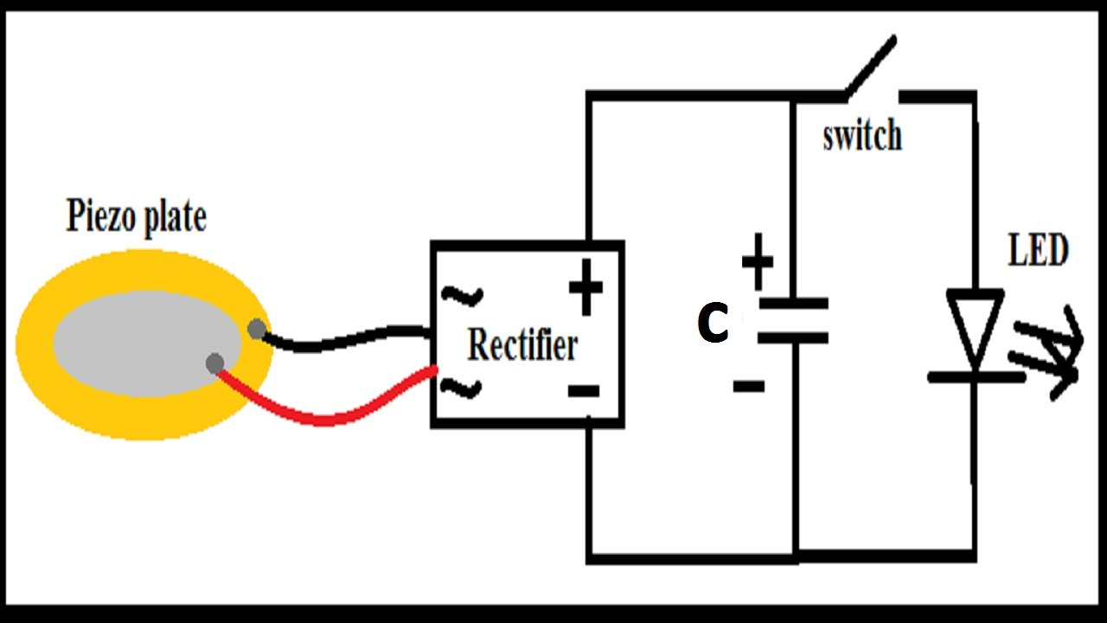

Fig. Wiring that can be used to glow the LED

**3. CONCLUSION AND EXTRA FEATURES**

**3.1 CONCLUSION**

* Although, the piezoelectric devices can have big applications, we will be presenting a smaller version of it, since we have limited resources. We will be modelling the same, but rather than storing the power, we will be directly using it to make a LED or a small bulb glow.
* India is a big country with dense population. Through this project, we will try to develop ideas on how to implement this to a greater extent, and solve the problem of power and energy to some extent.

**3.2 Extra Features**

* We can also count the number of steps that went through a mat by knowing the total power produced and power generated by a single step. Thus, it can also act as a counter.
* This can be used at various places where we don’t require a large amount of current.
* By using a parallel and series combination of some piezo discs, we can even produce voltage and current that would be enough for charging a cell phone.
* Placing the mat in congested place and footpaths can produce a good amount of energy, which can be used later.
* By bringing some minor changes, the idea being the same, we can also implement the same on roads, this would produce more power due to more applied force by the heavy vehicles. This technology may be used in charging electric vehicles in the future.